**Research on the impact and prevention of petroleum exploration and development on the marine environment based on remote sensing images**

**--Take a marine oil spill as an example**

Young Lights

【Abstract】The development of fossil energy, especially in the ocean, is very important to the future development of the world. However, the development of offshore oil, such as leakage, will have a serious impact on the marine environment, including pollution of the ocean surface and nearby beaches, death, and even extinction of marine life. Therefore, monitoring and timely treatment of marine oil spills is one arduous and urgent task. Synthetic Aperture Radar (SAR) has the advantages of all-weather, all-day, wide coverage, and high accuracy, and could become one of the important means of monitoring marine oil spills. Through statistics of major oil spills in the past 30 years, this paper shows that oil spills have caused serious economic losses, large-scale marine pollution, biological death, and even physical extinction and other devastating adverse effects. Then, Taking the major oil spill that occurred in Southern California in October 2021 as an example, the location and coverage of the oil spill were analyzed using Landsat 8 optical images and Sentinel-1 SAR images. Compared with the final confirmed oil spill location, it could be proved that remote sensing is a potential and powerful tool for oil spill detection, Whilst some measurements are proposed to prevent and control marine environmental pollution.

**Keywords:** Offshore oil exploration and development, marine environmental pollution, Remote Sensing Imagery, prevention and control measures

# Introduction

Due to the rapid development of new energy development in recent years, many scientists focus more on the technology and application of new energy development, ignoring the research on fossil energy. With the boost of the population, energy is being consumed in large quantities. The increased importance of petrochemicals in driving oil demand growth was also evident in the global product breakdown, with products most closely related to petrochemicals (ethane, LPG, and naphtha) accounting for around half of the overall growth in demand in 2018.

The human demand for oil energy is continuing to grow robustly, increasing 1.4 Mb/d last year, in China and India in particular, which provided a relatively stable backdrop (BP Statistical Review of World Energy, 2019), although oil demand in 2021 was 3.7 Mb/d below 2019 levels on average ([Statistical Review of World Energy | Energy economics | Home (bp.com)](https://www.bp.com/en/global/corporate/energy-economics/statistical-review-of-world-energy.html)).

In China's energy consumption structure, the proportion of coal is much higher than that of other countries. According to statistics, in 1990, 2002, 2005, 2011 and 2013, the proportion of coal consumption in the composition of energy consumption in my country was 76.2%, 68.0%, 70.8%, 77.8% and 66.0% respectively, and it still accounts for 76.2%, 68.0%, 70.8%, 77.8% and 66.0%. About 65% of the entire energy structure configuration. China`s coal-dominated energy structure is difficult to change in the short term, and the distribution of existing energy resources determines its current energy consumption structure dominated by fossil energy. With the largest energy consumption in the world, China's 14th Five-Year Plan established the concept of "fossil energy guarantees the constant status of energy in the modern energy system". Therefore, the research on fossil energy remains challenging Onshore oil has been explored for a long time and deeper excavation requires newer and more advanced technologies.

Relatively, the ocean, which accounts for about 70% of the earth's surface, is a treasure trove of resources for human survival. It contains rich oil and gas resources, natural gas hydrates, and ocean energy resources. It is becoming an important energy base and strategic space for human beings in the 21st century (Zhou et al., 2016). Its exploration and development have also attracted the attention of many national governments and scholars. At present, there are about 2,000 offshore oil drilling platforms (<https://www.eia.gov/>).

However, Marine pollution caused by offshore energy exploration and development, especially oil spills have devastating effects on the aquatic ecosystem. Oil slick monitoring has been becoming a mandatory and imperative research task, affecting profoundly marine development (Girard-Ardhuin et al., 2003; Hammoud et al., 2017). The process of exploration and development has had a great impact on the marine environment. Taking oil as an example, it has caused huge economic losses. Therefore, monitoring oil spills and proposing necessary preventive measures has become an inescapable and urgent research task. It has an important impact on the future development of the ocean.

Many scholars have studied the impact of offshore oil exploration and development on the marine environment and its prevention and control. For example, Zhou Shouwei and others reviewed the current status of offshore oil exploration and development technology, and put forward China's prospects for offshore oil exploration and development, indicating that deep water is the key area of ​​China's marine energy development and utilization, and China must expand the strategic space for economic development. "Vigorously develop deep-sea technology, strive to improve the ability of deep-sea resources exploration and development technology, safeguard my country's rights and interests in the international seabed, and realize the development of marine energy from land to sea, especially the deep-sea field (Zhou et al., 2016).

In the process of offshore oil development, oil spills have a serious impact on the marine environment, polluting seawater and causing marine environmental pollution; harmful substances carried in oil exist in marine animals and plants and are eaten by humans through the food chain. Threats to surveillance health; oil is viscous, causing the death of marine life and even species extinction, with far-reaching and irreversible impacts on marine ecosystems. The global oil spill management market is expected to be worth $192.06 billion by 2027, according to the Oil Spill Management Market report by Reports and Data consulting firm. Regarding the control of offshore oil spills, in addition to improving safety production standards and eliminating production and transportation accidents, the key to artificially reducing oil spill pollution in the face of marine oil spills is the timely discovery and reporting of accidents. It is necessary to quickly deal with the oil spill at sea before the oil spill area expands to be uncontrollable. For oil spill monitoring and management, the following questions need to solve: Where is the location of the spill? How much oil leaked or oil spill area? How fast and where did the oil spill spread? Who will be affected? Can the pollution be removed? In what ways? To deal with marine oil spills, the first step is to find the oil spill area. The oil spilled in the ocean with the currents, which requires a wide range of monitoring data.

The use of remote sensing image data can clearly and accurately capture the location, area, and diffusion speed of marine oil spills, to prevent/stop the further spread of oil in advance. At present, the main modes of marine oil spill pollution monitoring are satellite remote sensing monitoring, aerial remote sensing monitoring, ship remote sensing monitoring, fixed-point monitoring, and buoy tracking (Fingas et al., 2014; Hammoud et al., 2017;). Traditional aerial remote sensing monitoring and ship remote sensing monitoring generally belong to the category of "post-event monitoring" due to high operating costs and relatively small coverage. That is to say, the effectiveness of aerial remote sensing and ship remote sensing can only be manifested when an oil spill occurs and the time and location are known().

The cost of deploying aerial remote sensing monitoring and ship remote sensing monitoring on a large scale in the sea where no oil spill accident has been found is huge. Moreover, aerial remote sensing monitoring and ship remote sensing monitoring are greatly affected by climatic conditions, and normalized monitoring (real-time dynamic detection) will face many difficulties. Among them, fixed-point monitoring and buoy tracking can reduce the cost of high-frequency voyages for remote sensing of aviation and ships, but it requires large-scale deployment, and it is difficult to give an overview. In addition, the ocean area is vast, and monitoring by buoys is limited by cost and data transmission capabilities, and it is difficult to cover a large area.

Alpers et al. and Fingas et al. have highlighted the usefulness of Remote Sensing (RS) technology for offshore monitoring (Alpers et al., 2017, Fingas et al., 2011, 2014). In particular, Synthetic Aperture Radar (SAR) imagery has been identified as an effective tool for detecting marine pollution (Brekke et al., 2005, Angelliaume et al., 2018). SAR technology has the advantage that it is independent of sunlight, weather, and clouds and allows for global coverage. Moreover, Amri et al. utilized Sentinel-1 SAR imagery and contextual information concerning wind speed and proximity to human activities with domain expert photo-interpreters and deep learning to address oil slick detection. They demonstrated that their tool could speed up the detection to keep up with continuous sensor acquisition, such as SAR imagery and wind information. (Amri et al., 2022)

In short, satellite remote sensing monitoring covers a large area, and the satellite operates outside the atmosphere and is not restricted by meteorological conditions. It can fly normally and observe the sea normally under severe weather conditions on the sea. Satellites can inspect large-scale cross-sea areas. The oil spill detection capabilities of optical remote sensing satellites are limited by light conditions and can only be imaged during the day. However, even in the daytime, optical remote sensing images are easily obscured by clouds and rain and cannot fully detect oil spills. And, optical images are also interfered with by the color of seawater caused by illumination angle, seawater depth, and marine particles, which may not be accurate. , Consistently reflect the spread of oil spills.

Compared with optical remote sensing satellites, radar remote sensing satellites have natural advantages in the identification of offshore oil films, and can clearly distinguish the boundary area between offshore oil films and seawater, with a high recognition rate, low data processing workload, and low misjudgment rate. In addition, radar imaging is not affected by night shooting and cloud and rain occlusion. It can continuously monitor oil spill dynamics around the clock and in a large area, and accurately identify the location and scope of oil film distribution, which is extremely useful for monitoring and handling of oil spills at sea. Advantageous solution. Therefore, radar remote sensing satellites are the best means to monitor marine oil spills.

This study summarizes the current impact of offshore oil exploration and development on the marine environment, and the research status of real-time dynamic observation of the marine environment using RS satellite images. Taking the oil spill in Southern California in 2021 as an example proves the important role of remote sensing images.

The organizational structure of the article is as follows: the second part introduces the theoretical method of using satellite remote sensing image data to observe marine oil spills; the third part covers the statistics of major oil spills that have occurred in the past 30 years and the oil spills that occurred in Southern California in 2021. Satellite monitoring results, followed by conclusion and outlook. The fourth part is the conclusion, and the fifth part is the outlook.

# Method

This study`s methods include statistics and utilization of remote sensing images to observe and discover oil spills in advance.

1. Statistical method

The marine oil spills that have occurred in the past 30 years (since 1991) are analyzed and counted, with the economic losses and impact on the marine environment. The average and maximum numbers are utilized to illuminate the statistical results to illustrate the adverse effects of marine oil spills on the marine environment.

2. Use remote sensing images to observe and discover in advance.

1. Optical remote sensing images are presented using false-color composites of three bands. Non-professionals can also directly identify different features.

2. Synthetic Aperture Radar (SAR) images use microwave signals, and the principle for identifying marine oil spills are as follows: (Tian, 2009; Hu, 2015)

1) Use the strength of the backscattering coefficient of the microwave signal to determine the difference between objects on the ocean surface, including metal objects such as ship hulls that have strong backscattering, which is brighter and whiter than water on radar images. While oil is thick liquid and more sticky than water, so it is darker than water in the SAR images;

2) The satellite images are converted to the geographic coordinate system through the geographic coordinates, the position of the ocean surface can be determined, and the oil coverage area (1° = 111 km) could be calculated through the covered latitude and longitude.

# Results

## 3.1 Statistics of the major offshore oil spills in recent 30 years

Table 1 shows the statistics of 8 major offshore oil spills in recent 30 years.

**Table 1 Statistics of major oil spills in recent 30 years**

|  |  |  |  |  |  |  |
| --- | --- | --- | --- | --- | --- | --- |
| **No.** | **time** | **location** | **Oil leakage(gallon)** | **Economic loss(dollars)** | **Polluted ocean area (km2)** | **Number of dead or extinct marine life** |
|  | 1991.1 | Kuwait | 5,200,000,000 | No data | 144,000 | thousands of seabirds dead |
|  | 1992.12 | puerto a coruña | 15,483,870 | No data | No data | 200 km2 polluted area |
|  | 1996.2 | Wales | 1,470,000 | 80 million | No data | 250,000 seabirds dead |
|  | 2002.11.13 | Northwest Spain | 7,350,000 | 3 billion | 3,000 | thousands of seabirds dead |
|  | 2010.4.20 | Gulf of Mexico | 20,580,000 | 10 billion | 10,000 | 5 species of sea turtles are endangered |
|  | 2011.12 | Bohai Bay | No data | 2 billion | 276 | 5500 km2 polluted area |
|  | 2020.7.24 | Southern Mauritius | 294,000 | 50 million | No data | No data |
|  | 2021.10.2 | California Coast | 126,000 | No data | 65 | No data |
| AVG | —— | —— | 749,329,124 | —— | —— | —— |

According to table 1, for these events, the average oil spill volume (gallons) reached 749,329,124. The maximum economic loss caused by the oil spill reaches 10 billion. The maximum polluted ocean area reaches 10,000 km2 and thousands of sea lives were dead or extinct species. It can be demonstrated that the oil spill not only caused huge economic losses but also had a serious impact on the marine environment and its ecosystem.

## 3.2 A case in Southern California in 2021 utilizing RS imagery

Taking the oil spill that occurred in Southern California on October 2, 2021, as an example, by combining optical remote sensing images and SAR images, the location of the oil spill and the area of oil spill diffusion were analyzed and obtained.

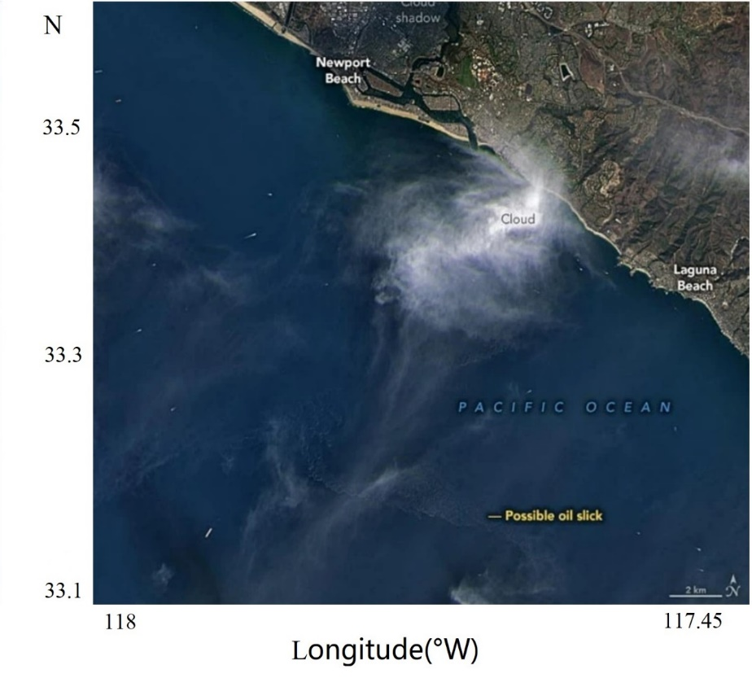

**Figure 1 Natural color view acquired by Operational Land Imager (OLI) on Landsat 8 at 11:22 AM PDT on October 3**

Figure 1 illuminates that a possible oil spill could happen in the location of 117.50°W，33.18°N on October 3, 2021.

Because optical images may have the phenomenon of the same spectrum of different objects, there are some other objects such as algae on the ocean surface that are consistent with the spectral characteristics of oil, so it is necessary to use SAR images to assist in the analysis.

Figure 2 shows the result of the Sentinel-1 SAR image. SENTINEL-1 is an imaging radar mission providing continuous all-weather, day-and-night imagery at C-band. The SENTINEL-1 constellation provides high reliability, improved revisit time, geographical coverage, and rapid data dissemination to support operational applications in the priority areas of marine monitoring, land monitoring, and emergency services. SENTINEL-1 potentially images all global landmasses, coastal zones, and shipping routes in European waters in high resolution and covers the global oceans at regular intervals. Having a primary operational mode over land and another over open ocean allows for a pre-programmed conflict-free operation. The main operational mode features a wide swath (250 km) with high geometric (typically 20 m Level-1 product resolution) and radiometric resolutions, suitable for most applications. (<https://sentinel.esa.int/web/sentinel/user-guides/sentinel-1-sar/overview>)

Level-2 Ocean (OCN) data for retrieved geophysical parameters of the ocean (systematically distributed). Sentinel-1 SAR image is downloaded from the Europe Space Agency (ESA) website <https://sentinel.esa.int/web/sentinel/sentinel-data-access> and <https://scihub.copernicus.eu/dhus/#/home>.

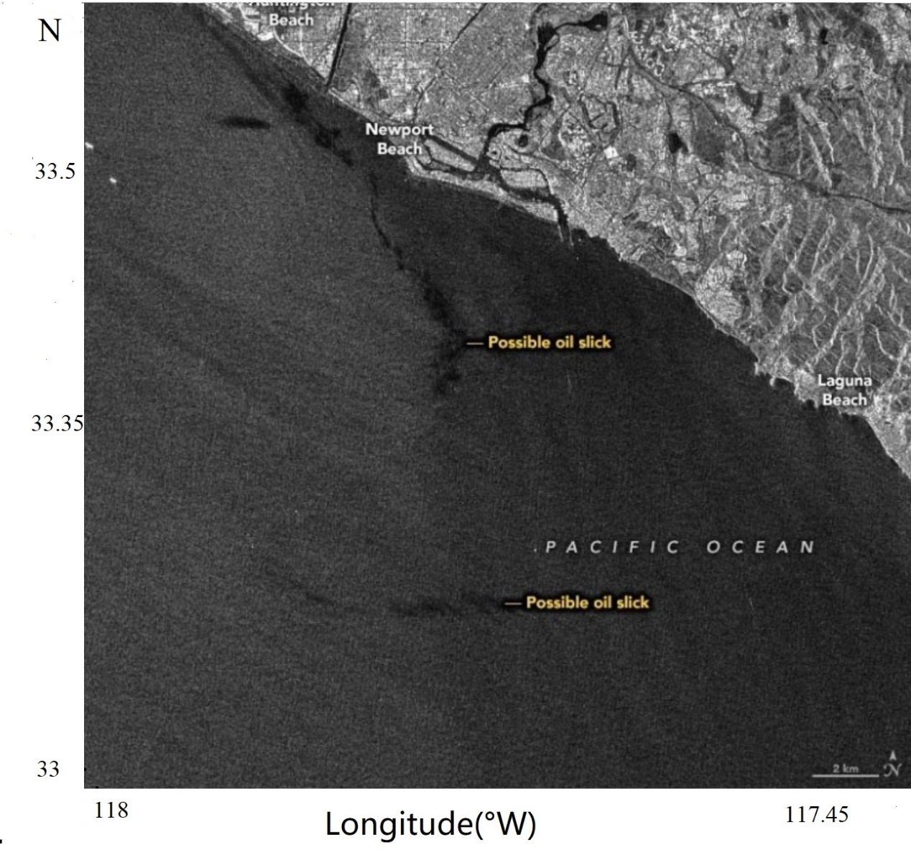

**Figure 2 Image taken by Sentinel-1 B at 6:49 PM PDT on October 2, 2021**

According to the theoretical method that oil appears darker than water. In Figure 2, the red areas are oil spill areas, 117.50 $°$ W，33.20 $°$ N, 117.52 $°$ W，33.40 $°$ N, respectively. Compared with the actual situation, it is consistent with the actual oil spill location. This further proves the accuracy of the remote sensing image results.

# Conclusion

By reviewing the research and demand for fossil energy in recent years, this study further confirms the important position of fossil energy in the next few decades and the imperative of marine energy exploration and development, especially oil. However, oil exploration and development are also accompanied by serious leakage risks. Statistics analysis has been done about the major oil spills that have occurred in the past 30 years. The fatal impact of oil spills on the economy, marine environment, and marine life is proved. It is imperative to take effective measures to prevent oil spill accidents timely. And the feasibility of using remote sensing images to realize oil spill monitoring is proposed. In particular, SAR remote sensing images have the advantages of all-day, all-weather, high precision, and wide coverage. The RS images could determine the location, the time, and the area in advance. They are one of the potential and powerful data sources for the construction of oil spill monitoring systems in the future.

# Outlook

Not only marine oil spills are an important threat to the marine environment, but other marine pollution, including plastics, wastewater, and nuclear radiation, also pose a great threat to the marine ecosystem. Therefore, some control measures need to be taken. Some measures are proposed as follows:

1. Marine sustainable development and environmental protection could be implemented by controlling pollution sources.

2. Further scientific research on the marine environment suggests investing more in material resources and attention.

3. It is imperative to improve the legal system of environmental protection and strengthen monitoring, monitoring, and management.

In the future, remote sensing images can not only be applied to the monitoring and prevention of oil spills but also will play a huge role in the real-time monitoring of marine pollution.

# Reference

1. 2020-2025 China Oilfield Industry In-depth Development Research and "14th Five-Year" Enterprise Investment Strategic Planning Report[C]. Beijing, 2020.
2. Alpers, W.; Holt, B.; Zeng, K. Oil spill detection by imaging radars: Challenges and pitfalls[J]. Remote Sens. Environ. 2017,201, 133–147.
3. Amri, E.; Dardouillet, P.; Benoit, A.; Courteille, H.; Bolon, P.; Dubucq, D.; Credoz, A. Offshore Oil Slick Detection: From Photo-Interpreter to Explainable Multi-Modal Deep Learning Models Using SAR Images and Contextual Data[J]. Remote Sens. 2022, 14, 3565.
4. Angelliaume, S.; Dubois-Fernandez, P.C.; Jones, C.E.; Holt, B.; Minchew, B.; Amri, E.; Miegebielle, V. SAR imagery for detecting sea surface slicks: Performance assessment of polarization-dependent parameters[J]. IEEE Trans. Geosci. Remote Sens. 2018, 56, 4237–4257
5. BP Statistical Review of World Energy[C], 68th Edition, 2019.
6. BP Statistical Review of World Energy[C], 68th Edition, 2021.
7. Brekke, C.; Solberg, A.H. Oil spill detection by satellite remote sensing[J]. Remote Sens. Environ. 2005, 95, 1–13.
8. Fingas M , Brown C E . Oil Spill Remote Sensing: A Review[M]. Elsevier Inc. 2011.
9. Fingas, M.; Brown, C. Review of oil spill remote sensing[J]. Mar. Pollut. Bull. 2014, 83, 9–23.
10. Girard-Ardhuin, F.; Mercier, G.; Garello, R. Oil slick detection by SAR imagery: Potential and limitation. In Proceedings of the Oceans 2003. Celebrating the Past. Teaming Toward the Future (IEEE Cat. No. 03CH37492), San Diego, CA, USA, 22–26 September 2003; Volume 1, pp. 164–169.
11. Hammoud B , Mazeh F , Jomaa K , et al. Multi-Frequency Approach for Oil Spill Remote Sensing Detection[C]// International Conference on High Performance Computing & Simulation. IEEE, 2017.
12. Han Ying. Tracing of Donghuang Oil Pipeline Leakage and Explosion Accident of Sinopec [J]. Labor Protection, 2014, 000(001):44-47.
13. Hu Guanhua. Oil film extraction and edge detection based on synthetic aperture radar marine oil spill images [D]. Tianjin University, 2015.
14. Sentinel-1A data product user guide and The Sentinel-1 Technical Guide. <https://sentinels.copernicus.eu/web/sentinel/technical-guides/sentinel-1-sar>.
15. Tian Wei. Research on the mechanism and method of remote sensing detection of sea surface oil film radar [J]. Institute of Remote Sensing Applications, Chinese Academy of Sciences, 2009.
16. Zhou Shouwei, Li Qingping, Zhu Haishan, et al. Current status and prospect of offshore energy exploration and development technology [J]. Engineering Science, China, 2016, 018(002):19-31.